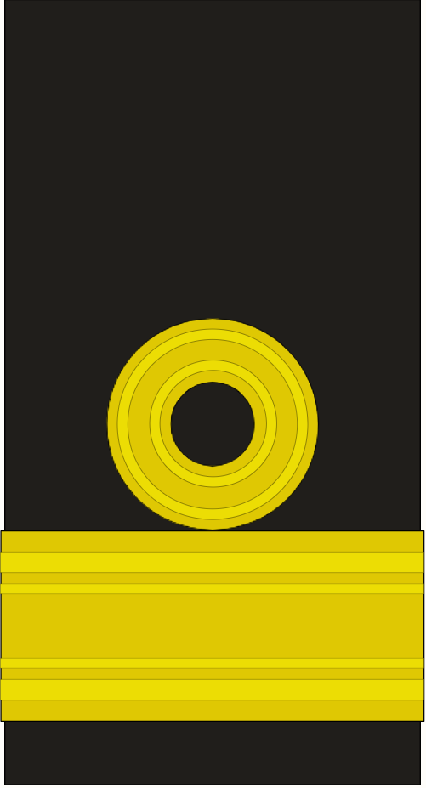

**©**

**Commodore Copyright**

Insignia: Public Domain (Rank OF6, UK Navy). This work: CC0.